**Lab Assignment 3**

**I. Introduction:**

In this we tried to implement a text classification using Convolutional Neural Networks with the help of RNN and LSTM, which is to find the best method that gives the best accuracy and very less loss. LSTM overcomes the drawback of RNN that is to overcome the gradient vanishing.

**II. Objectives:**

The primary task is to compare the results using CNN, RNN and LSTM by analyzing every classification over neural network.

**III. Approaches/Methods:**

1. Initially the data is loaded from the data-set.
2. Then we need to set up the parameters for training model.
3. Then the classes and functions need to imported required for the train model.
4. We use Adam Optimizer for construction of CNN model.
5. Modify the data by removing extra things like spaces to make data processable.

**IV. Workflow:**

1. **CNN output:**

**A screenshot of a social media post

Description generated with very high confidence**

1. **RNN output:**

A screenshot of a social media post

Description generated with very high confidence

1. **LSTM output:**

**A screenshot of a social media post

Description generated with very high confidence**

**V. DataSets:**

The data sets used here is IMDB data which is given in the final exam in which the data contains a corpus of 25000 samples.

**VI. Parameters:**

Below are the parameters that I have set for running this model

* max_features, max_length, batch_size, filter, Kernel_size, epoch and so on.

**VII. Evaluation and Discussion:**

Accuracy using LSTM is 0.8366

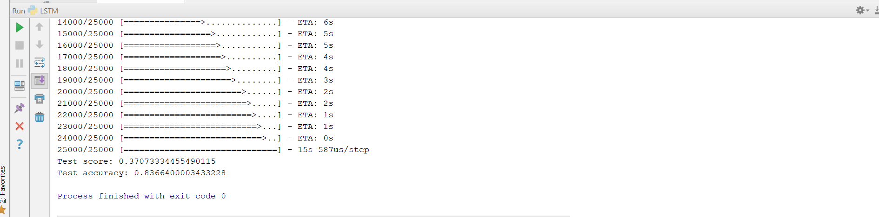

Accuracy using CNN is 0.8008

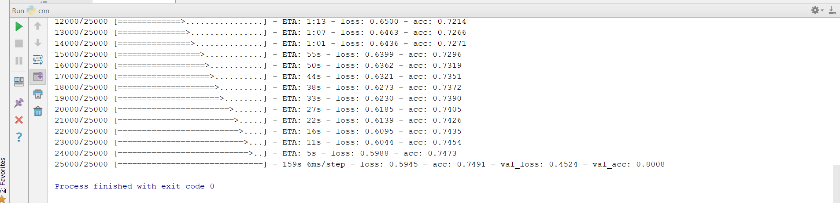

Accuracy using RNN is 0.551

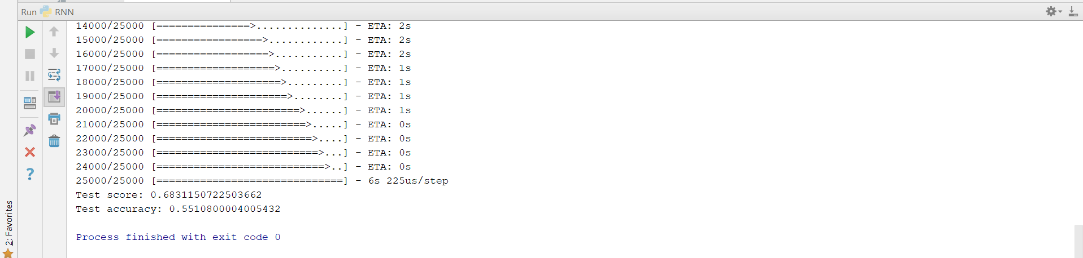

**VIII. Conclusion:**

LSTM performs better than RNN and CNN as it overcomes the Vanishing Gradient.

**IX. References:**

* [**https://www.tensorflow.org/programmers_guide/**](https://www.tensorflow.org/programmers_guide/)
* [**https://github.com/keras-team**](https://github.com/keras-team)